BREEDING HISTORY OF JAPANESE BEEF CATTLE AND
PRESERVATION OF GENETIC RESOURCES AS ECONOMIC FARM
ANIMALS

Dr. Kiyoshi Namikawa
Executive Director

INTRODUCTION
Modern beef cattle used for our beef production are not exactly a property left by our ancestors, but composed products from native and imported cattle. Most native cattle were graded up by British and continental breeds for a few generations about 90 years ago. It should be pointed out, however, that they are the sole domestic farm animals in our country contributing to practical animal production at present, originating from our native animals.

Four native beef cattle breeds were fixed from a mongrel population by strict selection over more than 50 years. Since the time of fixation as a pure breed, each breed is kept under a completely closed breeding system, excluding the crossing among them.

In this paper, breeding history and present aspects of Japanese Black breed, which is the major breed and distributed nationwide, will be described to discuss the way of preservation of genetic resources as economic farm animals at any period.

OUTLINES OF JAPANESE LIVESTOCK PRODUCTION

The major animals used in all segments of our livestock production were originally, and still are, imported. The unique developmental processes of our production would have some relation to the fact. Several principal factors influencing the unique processes can be pointed out.

Natural environment – The natural environment of our lands is suitable for grain, mainly rice production, as the most efficient means of food supply. Change of the four seasons is not proper to maintain good grassland conditions all year round, and grazing areas could not be found easily, outside of remote places in the mountains. Furthermore, our ancestors might be blessed with fishery products from the surrounding sea, and wild animal’s meat from the forest. They did not regard their farm animals as an animal protein source, while draft animals were indispensable for cultivating paddy fields.

Needs of farm animals – Over about 1,200 years, there had been no public demand for animal products, such as meat and milk, until the Meiji Restoration in 1868, because of religious reasons of Buddhism and Shintoism. It is an established theory that Japanese ancestors did not domesticate by themselves large animals, such as horses and cattle; immigrants brought those animals from the Asian continent.

Therefore, they were very valuable property for people who wanted to have as a labor source. Horses had been placed under the control of governors at any age on needs for the military use, while cattle entrusted to private leaders, such as rich farmers, priests and cattle dealers. Cattle had been needed not only for farming, but also for other industries such as mining, forestry and transportation.

Above all, cattle were particularly useful for farming, supplying labor and fertilizer to increase rice yields, instead of eating their meat. The demands for cattle as agricultural use continued until about 1960, when the mechanization of farming and mass production of chemical fertilizer prevailed. Cattle were called “agricultural treasure” during long periods. Then, poor farmers could not buy one such expensive animal.

Isolation – From a genetic view point, it would be interesting that the Japanese cattle had been isolated substantially over 200 years. Isolation is liable to occur in the island country, although there were some cultural interchanges between adjacent countries from old era. A noteworthy event is the national isolation enforced by the Shogun in 1635. This isolation lasted for two centuries to 1854, with exception of foreign trade with China and the Netherlands. There had been essentially no introduction of new genes to out cattle population during the period.

BUILD-UP OF OLD INBRED STRAINS IN NATIVE CATTLE

Discovery of old inbred strains – A serial survey on “Tsuru-ushi” (Tsuru = bine zure; Ushi = cattle), initiated in 1941 by Professor y. Habu and co-workers, revealed that the oldest inbred strain of native cattle was built up in 1830 at a traditionally famous producing area in Okayama Prefecture, along the Chugoku Mountains. Cattle belonging to the strain had won fame and had been sold at a special price. Three other inbred strains were also built up a little later at the near regions (Fig.1).

BUILD-UP OF OLD INBRED STRAINS IN NATIVE CATTLE
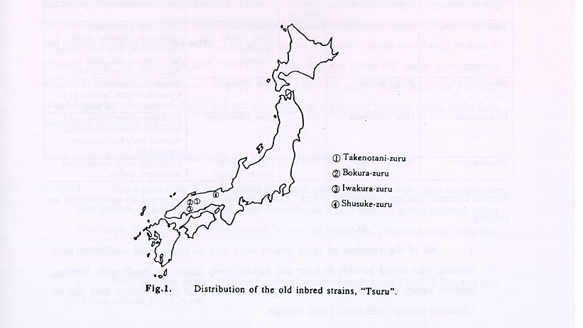

The feature of the old inbred strains – The term of “Tsuru” (sometimes pronounced “Zuru”) means a bine of plants, and has been used as a popular name of the inbred strain in native cattle. Then, “Tsuru” included a group of related cattle belonging to the strain and representing superior and common external and productive traits for that strain, because of similar genetic make-up. For example, cattle of “Takenotani-zuru” originated from one excellent cow, producing 19 calves during her 23 years of life. Two daughters inherited clearly their dam’s superior characteristics, as shown in Table 1, and they formed two sub-strains. A son was backcrossed to his dam to fix these traits, especially body size and diary character. Two bulls were selected among offspring produced by son and mother mating. Cows of this strain were sired with one of the bulls reciprocally in the successive generations. The breeders of this strain, Naniwa family, adopted
logical breeding techniques at such old time. Furthermore, they reserved a greater part of the females within near villages to observe their progeny.

Table 1. The oldest inbred strains.
Name of Strain | Region Built-up | Year  Built-up | Range | Main Characteristics
Takenotan-zuru | Atetsu, Okayama | 1830 | Atetu, Okayama, Hino, Tottori, Nita, Shimane Nogi, Shimane | Large size, good udder, soundness, longevity, serial reproduction, horn color, strong back-line and loin, mild disposition, fullness of hind.
Bakura-zuru | Nita, Shimane | 1855 | Nita, Shimane | Similar characteristics of Takenotani-zuru, because of a branch strain of the listed above.
Iwakura-zuru | Hiba, Hiroshima | 1843 | Hiba, Hiroshima | Mild disposition, lovely looks, longevity, serial reproduction, superior body conformation, good udder
Shusuke-zuru | Mikata, Hyogo | 1845 | Eastern part of Mikata, Hyogo | Longevity, serial reproduction, soundness, quality

Several common features among the oldest “Tsuru” shown in table 1 could be summarized as follows:

1. All of the breeders of these strains were rich farmers, cattle dealers or iron-masters who would be able to keep and handle many cattle. In small-scale farming, farmers hardly wanted to raise many expensive animals for labor service; they had no chance to compare and select better animals.

2. The breeders had some suitable grazing area and raised their cattle under good feeding and management conditions to enable distinguishing true ability on the important traits.

3. All strains founded as maternal strains, because reproductive and growing performance records were observed only for females in some closed place from their farm.

4. These strains induced branch strains in neighboring regions.
5. These gradually lost their good reputation with lowered superiority shown by distant descendants, not-with-standing their name value. Such properties might be inherited to present cattle in a broad sense.

Estimated characteristics of pure native cattle – All modern cattle, including the Japanese Black, are not breed-true of old native cattle, because they are descendants of mongrels between native and various kind of imported cattle. Characteristics of pure native cattle would only be able to estimate from old documents and “Mishima” cattle that are preserved under governmental protection as a natural monument (Fig. 2). These cattle are reserved in “Mishima”, a small island located in the Sea of Japan, and are recognized as a group of isolated native cattle from crossing with foreign breeds.

Some characteristic summarized by Dr. M. Ishihara are as follows:

1. Black coat color is predominant and black cattle with small white sport on udder or near bottom, or a little amount of white hairs on black skin seemed to be preferred, rather than single black pattern. White spotted, brown and blond-like patterned cattle were also present.

2. Body size was small. Withers height of mature females was 115-118 cm, and that of males about 123-125 cm.

3. Middle part of body was plump with well-stand ribs, but hind legs and neck were thin

4. Quality of coat and skin were fine, and hair was curled. Horn represented bluish-white color, fine texture and round section. Body shape was clean-cut, and shanks were fine with strong joint and tendon. Hooves were firm. Movement was smart.

5. Heifers were sired at more than 24 months of age for the first calving, while young bulls were used at three years of age for service, and bulls of five years of age were able to serve 80 females per year.

6. The abilities of drafting and carrying were a little inferior, but working will and turning action were superior to the modern Japanese Black.

7. Maximum milk secretion was about 3.3 kg per day, and lactation period lasted about 116 days; although there were wide individual variations on dairy performance.

8. Body weight gain and feed efficiency were low, but excellent meat quality was a common character.

It is clear that the requirements for old native cattle were directed to important traits of working performance, because of lack of utilization for dairy and meat production. The requirements were ignored when they were crossbred later with foreign breeds, expecting to obtain large-sized and superior dairy performance.

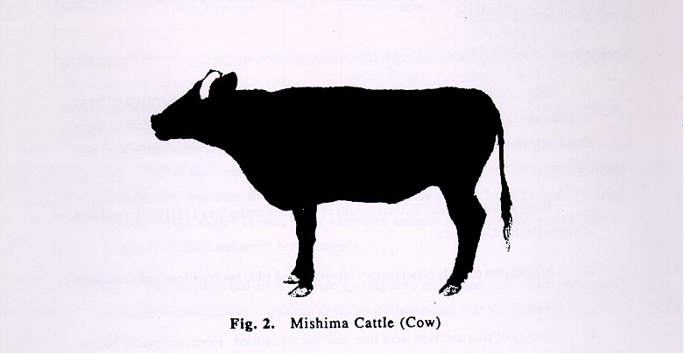

CROSSING WITH FOREIGN BREEDS
Promotion on the importance of foreign breeds – After the Meiji Restoration in 1868, the new government was eager to introduce Western food habit as well as culture. As it released the inhibition of eating farm animal meat and promoted drinking of milk, the consumption of animal products increased gradually. The government decided to import live animals for breeding use in 1868. About 65% of imported males and females were planned for pure breeding among important ones, and remained 35% were mostly bulls to be used for crossing with native cattle. About 2,600 head of cattle were imported by 1887. Farmers in the Chugoku districts did not show any concern to foreign breeds at first, but crossbreeding became common use in the early years of this century, being stimulated by the high prices of crossbreds at markets. However, the price of crossbreds fell suddenly in 1910 as crossbreds were regarded as undesirable “improved” inferior animals especially on working performance. The results of the crossing damaged farmers so heavily that a state of panic occurred here and there. No more crossing with foreign breeds was repeated thereafter, and troublesome problems remained to save the situation. Crossbreeding at that time would be a quite ill-advised attempt without clear objects. It appears that there must be a very simple anticipation to improve native cattle with large-sized and superior dairy performance, beside the fact that the most important economic trait for farmers was placed on working performance. Some parts of the anticipated were certainly realized in body size and milking performance, but quality traits of live animals and meat were lowered. Thus, the overheated period of crossbreeding had ceased within 10 years.

Peculiarity of crossing practices – In general, bulls from a selected breed are usually introduced to improve on a few important economic traits, when native animals should be graded up. At that time, Shorthorns and Devons were imported in the first years. But various breeds were introduced in the latter by the government, prefectural governments and companies. The imported breeds crossed with native cattle are shown in Table 2. These are different among prefectures and even among regions within prefecture. In addition, the degrees of influence of these breeds to native cattle raised in each region are also different. The crossing practices lacked consistency, and the reasons why these breeds were selected was obscure, even though gene pools were expanded at a stroke.

Table 2. Foreign breeds crossed with native cattle in each prefecture.

Name of Modern breed | Prefecture | Crossed Foreign Breeds
Japanese Black | Kyoto | Brown Swiss
 | Hyogo | Shorthorn, Devon, brown Swiss
 | Okayama | Shorthorn, Devon
 | Hiroshima | Simmental, Brown Swiss, Shorthorn, Ayrshire
 | Tottori | Brown Swiss, Shorthorn
 | Shimane | Devon, Brown Swiss, Simmental, Ayrshire
 | Yamaguchi | Devon, Ayrshire, Brown Swiss
 | Ehime | Shorthorn
 | Ohita | Brown Swiss, Simmental
 | Kagoshima | Brown Swiss, Devon, Holstein
Japanese Brown | Kochi | Simmental, Korean Cattle
 | Kumamoto | Simmental, Korean Cattle, Devon
Japanese Poll | Yamaguchi | Aberdeen-Angus
Japanese Shorthorn | Aomori | Shorthorn
 | Iwate | Shorthorn
 | Akita | Shorthorn, Devon Ayrshire

Fixation of modern breeds – According to the decision by the government, selection and registration started on the so-called “Improved Japanese Cattle” in 1919. The name means that cattle have superior traits brought about from both native and foreign ancestors. Again, it should be noted that a peculiar concept of the breed was found in the latter basic policy. There were so wide variations on the true type (pictured in each region) that the decision of objectives was left to each prefectural organization. These actions may come from an old sense which was fostered during the feudal age. By the way of fixation, these targets and organizations were integrated gradually, but the semen of active bulls seldom passed beyond the borderline of each prefecture. It seems that various sub-breed groups are immanent within the Japanese Black breed which distribute widely, although three modern breeds were regarded respectively as a fixed breed in 1944, mainly depending on their external characters.

FRAMING SYSTEMS OF MODERN INBRED STRAINS AND PLANNED PRODUCTION OF SUPERIOR BREEDING STOCKS IN JAPANESE BLACK BREED

Framing systems of modern inbred strain – A program to establish modern inbred strains came into effect in 1950 in advanced producing regions, which overlapped mostly with those of the oldest inbred strains. The most different point compared with the build-up of the oldest inbred strains was the basis of breeding unit. In this case, a group of farmers constructed a breeding unit. Each breeding group had to be qualified by the registry association according to the arrangement for breeding and had to follow on the mating recommendation. As shown in Figure 3, nine candidate groups started to establish modern inbred strains, but only four groups were successful. Kinds of lethal or defect genes were exposed by inbreeding in one group. The number of cattle from which breeding stocks were selected was not sufficient in another group. It must be very difficult to fix a set of desirable genes selectively concerning to all important traits, even though all other obstacles could be removed.

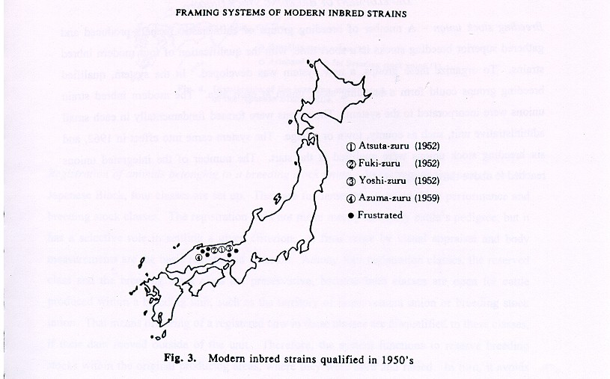

Program for planned production of superior breeding stocks – In the next step, crossing between or among established inbred strains, that is incross, was organized systematically to get superior breeding stocks in 1959. Five prefectures in the Chugoku districts cooperated in the program, regardless of the presence of the qualified new inbred strain. By this means, complementary on the plural important traits might be expected. Many bulls contributing to the present populations were products of the program, and they were serving to keep the inbred strain and also to level up all calves in the prefecture. Under control of the registry association, each inbred strain union could obtain the semen of the designated bull, even if it was raised in other prefectures. The demonstration of incrossing influenced very much to the general mating system in various producing areas, especially in newly developing areas. A greater part of the present Japanese Black originates from two or three different ancestral strains in their pedigree, although the ancestral strains do not mean exactly the modern inbred strains mentioned above.

DEVELOPMENT OF BREEDING STOCK UNION

Breeding stock union – A number of breeding groups of enthusiastic farmers produced and gathered superior breeding stocks in a short time, with the qualification of four modern inbred strains. To organize these groups, a new system was developed. In the system, qualified breeding groups could form a breeding stock union at each area. The modern inbred strain unions were incorporated to the system. The unions were formed fundamentally in each small administrative unit, such as county, town or village. The system came into effect in 1962, and six breeding stock unions were qualified at the start. The number of the integrated unions reached to above thirty now (Fig.4).

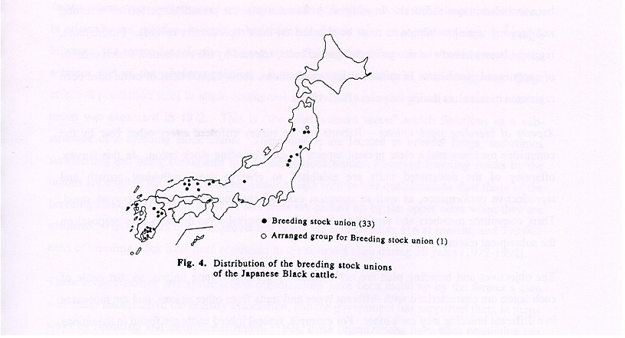

Registration of animals belonging to a breeding stock union – In the registration system for the Japanese Black, four classes are set up. They are fundamental, reserved, high performance and breeding stock classes. The registration does not mean merely to certify cattle’s pedigree, but it has a selective role in settling a given criterion. A final score by visual appraisal and body measurements are the basic registration criterion. Among four registration classes, the reserved class and the breeding stock class are preservative, because both classes are open for cattle produced within a breeding unit, such as the territory of improvement union or breeding stock union. That means offspring of a registered cow in these classes are disqualified to these classes, if their dam moved outside of the unit. Therefore, the system functions to reserve breeding stocks within the original producing areas, where they were born and raised. In turn, it avoids dispersion of favorable genes related to some traits.

Cattle belonging to a breeding stock union should be highly specialized elites as a useful material for subsequent programs, as the unions are qualified to make up new inbred strains. To be registered in the class, animals have to meet various qualifications. Pedigree, birth and raising place, cleanness on the undesirable genes, final score of judging and performance of calves have been included in qualifications. In addition, bulls must pass the prescribed performance testing and progeny testing, while cows must be checked on their reproductive records. Furthermore, registered cows have to be sired with designated bulls, selected by the committee, which consists of experienced specialists. In spite of strict qualifications, about 12,000 head of cattle have been registered in this class during 26 years (1962-1988).

Aspects of breeding stock unions – Reports on the survey enforced every other year by the committee members make clear present aspects of each breeding stock union. In this survey offspring of the designated bulls are exhibited to observe their individual growth and reproductive performance, as well as common external characteristics of the surveyed strain. Then, committee members and producers discuss in the workshop to decide a new proposal on the subsequent mating.

The objectives and breeding plan are not necessarily uniform among unions, so that cattle of each union are characterized with different types and traits from other unions, and are moreover in a different breeding step each other. For example, typical inbred cattle are found in the unions formed in Hyogo Prefecture, as there was no introduction of new genes from other breeding units during the past 90 years, and they have crossbred with foreign breeds. These cattle are characterized by genetic excellence in beef quality and have yielded finely marbled beef, which is famous with the name of “Kobe-beef” or “Matsuzuka-beef”. It may be an incorrect understanding that high quality beef is produced by special feeding and management techniques such as massage or beer drinking. Hiba Breeding Stock Union in Hiroshima Prefecture is another interesting example. This union has maintained the progeny from one of the oldest inbred strains in a broad sense, and cattle of the strain are characterized by their body type, growing and dairy performance. The union planned to mate selected cows with bulls kept in “Mikata” Breeding Stock Union, being the succession from one of the oldest inbred strains in Hyogo Prefecture. Much effort is concentrated to make up an improved inbred strain in the union, based on bulls and cows obtained from incrossing. There is no further gene introduction from other strains at present. In most unions qualified recently, similar breeding plans with the Hiba Union were adopted, but in some cases more than three strains are combined to introduce desirable genes into their breeding unit.

Improvement union and reserved registration class of breeding stocks – The registration system is originally not positive, because it had been considered as a means for culling. It is used, however, as a means for selection in our system. Selected breeding stocks would be certainly be a minor part of the whole population. It is necessary to maintain wide background (large effective population size) to attain continuous improvement. In this direction, another class of union was organized in 1972. This is “the improvement union” which functions as a sub-structure or a breeding stock union. These unions are located in broader range, sometimes surrounding and being contiguous to a breeding stock union. Reserved breeding stocks by the unions are eligible for the reserved registration class with milder qualifications than those of the breeding stock class. Some cattle of this class are picked up by the upper class when they are qualified. The numbers of the improvement union are accounted as 616 at present, and 790,000 head of breeding stock have been registered in the reserved class during 20 years (1972-1992).

These comprehensive and systematized organizations have been made up by the farmer’s own will under leadership of the registry association, and the government has supported them in many ways by financing and institutionalization. Thus, these organizations have been promoting our beef cattle improvement, preserving genetic resources within productive populations.

PERFORMANCE AND PROGENY TESTING PROGRAMS

Establishment of testing procedures – The concept of the progeny testing arose in the early 1950’s, followed by the development of young steer fatting systems. In the traditional fattening systems prevailing before this development, cows, and in some cases heifers, were the main feeder cattle that were provided for fattening after working use. In most countries, where the main purpose of cattle raising was placed on agricultural or miscellaneous working, old cattle have been used for beef production as a by-product. Therefore, it seemed to be quite difficult to develop standardized beef production system. By the mechanization of agriculture initiated from about 1950, beef production by Wagyu had to change to a new fattening system, based on steer calves as feeder animals, by which standardized and popular fattening systems could be brought about.

Researchers preceding Professor S. Uesaka started their works on the procedures of progeny testing. The final procedures were completed in 1962. In the next year, the procedures for performance testing were presented them.

Start of the performance and progeny testing programs – The official performance and progeny testing programs started in 1968, and records from these tests were introduced to registry certificates. The number of tested bulls has quickly increased every year (Table 3).

These tests were carried out at the testing station in each prefecture, without any central testing station. This fact caused later definite difficulty in adjusting environmental effects and evaluation on the genetic merits.

Table 3. Trends of the number of performance and progeny tested bulls.

Year Performance Tested Progeny Tested

1968 111 14
1970 99 17
1975 353 37
1980 338 61
1985 371 83
1990 355 92

Unexpected defects of the present program – In our testing programs, bull calves from 6 to 7 months of age are full-fed in individual pens for 112 days. Selected fast growing calves can proceed to the progeny testing program. In the progeny testing, 8 to 10 steer calves of candidate bulls, ranging from 7 to 8 months of age, are group-fed for 364 days. There are, however some unexpected defects in this program when we place the first emphasis on the improvement of carcass quality traits. We may lose superior potential bulls that may be excellent in carcass quality traits at the first step of selection based on the performance testing records. Furthermore, limited information on the sire’s performance and carcass traits is not sufficient to select effectively bull candidates being excellent in both performance and carcass traits.

It may also be a limiting factor for this program that the number of tested bulls can not increase drastically because of the costs for facilities and feeding. We had to seek a more effective program.
Promotion of breeding value evaluation program – In 1998, the beef carcass grading standard was revised to cut carcasses at the same rib-section throughout all carcass markets where carcass grading had been enforced. Standardized evaluation techniques were also introduced. The revision gives us a very nice chance to proceed to the field progeny testing program, by which we are able to estimate breeding values on carcass traits of both sires and cows. After 3 years of trial, the breeding value prediction program on carcass traits by field progeny testing records was initiated in 1990. Animal Model BLUP is used for this program.

CHANGEOVER OF BREEDING POLICY AND GOALS IN THE LATEST REVISION ENFORCED IN 1989

Attained improvement in mature size and growing rate of Japanese Black – As an overall inference, it may be mentioned that the strongest selection intensity has been placed on mature size and growing rate of Japanese Black throughout the historical breeding processes, including crossbreeding with foreign breeds in the early time of this century. This statement must be well substantiated by the indication of objective figures of body measurements in all of the judging standards adopted in each stage. Actually, the judging score of live animals has shown very close correlation with such body measurements as withers height and body weight. As a result of the concentrated efforts on those traits, registered Japanese Black generally doubled in their mature body weight, compared with native Wagyu. Some parts of such a consistent policy seem to be intensified by a series of importations of British and Continental beef cattle to attain their growing rate and beef type conformation. It must be indispensable, however, to consider that size of cattle is the most appropriate and efficient for our domestic beef production at present and also for the future.

Uniformity of mature size and growing rate in Japanese Black – The mature size and growing rate of Japanese Black are still very variable among strains within the same breed. The uniformity of main economic traits is essential, even though the diversity of economic traits should be maintained in the breed from not only genetic, but also economic viewpoints. As carcass quality traits of Japanese Black are also variable, the primary emphasis of breeding policy should be switched to the uniformity of all economic traits, instead of the absolute level of each economic trait.

Newly settled goals on body size – In the previous revision, goals of mature cow size shown by body measurements and weight had always been leveled up. In the new objectives, however, the goal of body measurement was settled on 129 cm in withers height and 540 kg in body weight.

These figures show averages t 35 months of age on the revised normal growth curve. Large sized animals which surpassed the upper limit of normal growth range (д + 1.5 ơ) do not regard any more than an excellent grower, although the rating on growth is still not symmetrical in both sides of the average growth curve.

SUPPLEMENTARY STANDARDIZATION RELATED TO THE EXTERNAL EVALUATION OF LIVE ANIMAL

Condition score: In the evaluation of the live animal, the judging score by the judging standard has been used traditionally as the comprehensive indicator of basic performance, such as reproductive, mothering and growing abilities. One complicated problems was the rating on the nutritional condition. Nine class rating methods were newly introduced in this revision. As a rule, judging should be done on the standardized condition range, because modified conformation by subcutaneous fat does not give us reliable data of the evaluation.

The data and exponential equation used for normal growth curve estimation: The first nationwide Wagyu show was held in 1953 under sponsorship of our association, and since then the show has been held every five years. Since the third show, this serial of events has been called “Wagyu Performance Show.” It means that all records on growth feeding and management of enrolled cattle have been collected during the year prior to each show. These data have been used for the estimation of revised normal growth curves using Brody’s equation. The normal curve and normal range estimated by such a way are not adequate for all Japanese Black, because cattle enrolled for the shows were selected strictly in each producing area on their growth rate and conformation. Therefore, the growth curves obtained from these data tended to show higher levels than those of the average curve by all animals. The new normal growth curve in the revision was established by all available data stored in the host computer of our association to synthesize more real growth pattern of Japanese Black. In the next revision, we will be able to use longitudinal data obtained on the individual animals randomly chosen from various improvement unions. To get the revised normal growth curve, several non-linear equations will be compared on the fitness to the data, and the best one will be adopted.

Introduction of judging by descriptive classification score: A new descriptive classification score was devised in the latest revision to adopt for the high performance registry. The system includes a total of twenty-six items of external characteristics to get hold of general features of each animal by five class ratings on each item. One of the purposes for the introduction of the system is its usefulness for a training course for inexperienced judges. The second purpose is its convenience for producers to understand external characteristics of their cattle. Thirdly, it seems to be useful in order to estimate genetic parameters of the external characteristics and to investigate mutual genetic relationships with other economic traits.

In our Wagyu improvement, body measurements must be a unique existence as an indicator of some genetic performances, because Wagyu is very mild in their temperament so that it is very easy to handle them for measuring body size. Within a couple of years, we will be able to estimate breeding values of the external characteristics and body measurements.

BREEDING VALUE PREDICTION ON CARCASS TRAITS, AND SELECTION AND MATING BASED ON THE PREDICTED BREEDING VALUES (PBV)

Selection and preservation of superior breeding stocks in meat quality traits – As mentioned previously (Chapters VI and VII), we have prepared for the breeding value prediction on the carcass traits, especially on the meat quality traits, under “animal Model BLUP”. In the usual procedures, there was no reliable indicator to detect breeding cows, which had a high ranking of breeding value on “Beef Marbling Standard (BMS)”. Lacking of an alternative, pedigree information has been used to estimate their ability on this trait. It often has been observed at carcass competitions that carcasses of heifers and steers showed quite an excellent degree of marbling, while the records of the official progeny testing of selected bulls in the same prefecture was unexpectedly low. Such a kind of loss of genetic resources has not been a rare case. If it is possible to predict breeding values on both the sire and dam, we will be able to evaluate preliminarily their son at or before the mating. By this means, selected bull calves will be sent to the performance testing, and probability of superior bull production on this trait will become higher.

Furthermore, animals ranked high orders on Predicted Breeding Value (PBV) will be preserved completely in the producing area, enabling the reproduction of excellent breeding stocks in the planned mating.

The most effective utilization of pedigree information – There are about 60,000 to 70,000 head of registered animals every year in Japanese Black population. Most registered animals within the same prefecture have common ancestors in their pedigree notes, since more than 95% of matings have depended on artificial insemination. As a result of this situation, relative relationship among registered animals may be useful for making breeding plans of populations classified by each prefecture. Since our association has accumulated a large amount of pedigree records on the most important property, we have to consider the most effective utilization of the property.

Systematic carcass data collection – There is no clear specialization between calf production and feedlot management in our beef cattle production, compared with foreign situation. It means that systematic carcass data collection will be possible without troublesome disagreement between both segments. In addition, more than 80% of slaughter steers are graded at the meat markets in the ordinary marketing. Therefore, we can expect to feedback such field data as a reliable source for improvement by matching with pedigree information. It is quite a favorable situation for us, because our domestic beef production depends mainly on purebred feeder calves.

Regional estimation of breeding value by a personal computer – In our breeding value prediction program under animal model BLUP initiated in 1990, each prefectural branch office of our association is responsible for evaluation and management of carcass data and predicted breeding values (PBV).

This fundamental scheme is originated from several considerations as follows:

1. It is impossible to predict breeding values in nationwide range at present. As shown in Figure 5 and Figure 6, estimated heritabilities of the same trait differ considerably among prefectures. It must be brought about by the difference of genetic make-up of cattle between prefectures. Furthermore, environmental effects can not be removed completely by all means.

2. PBV should be managed to devote to breeding purpose only, at least in the present situation, in order to protect taking out necessary breeding stocks for commercial purpose and use as feeder cattle. It is the general understanding that owner’s property must be managed by owners.

3. Selection and preservation of breeding stocks should be decided by the latest PBV as soon as possible, looking for the animal on their external characteristics. It is the best way to calculate the latest PBV by themselves any time it is necessary.

4. The cost for computation can be saved to lower the level of use of personal computers.

Planned mating of each cattle based on PBV – Within about 5 years, most of the breeding cows must have their own PBV on carcass traits. It is feasible at that time that each cow mate with the most matched sire to produce calves balanced in various important carcass traits. In addition, in the next step, both sire and dam must be evaluated with fundamental economic traits and carcass traits, by which the improvement of Japanese Black may be accelerated much more.

There is a wide variation in the PBV of carcass traits at present, even though between two sires categorized within the same strain (Table 4). The combination of PBV on a couple of traits is quite different between sires from the same origin. A similar situation exists between cows belonging to the same strain.
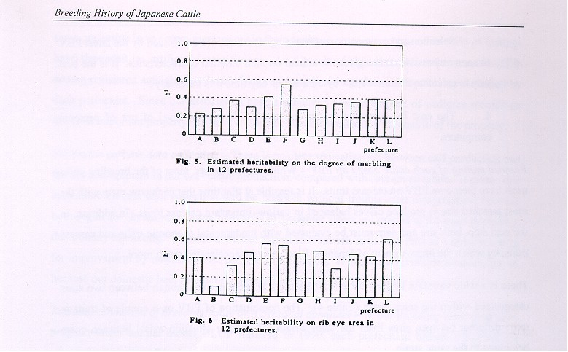

Table 4. An example of predicted breeding values on popular sires in certain prefecture.

Name | Type classified  Before genetics evaluation | Carcass weight (kg) | Ribeye area (cm²) | Thickness of middle rib (cm) | Subcutaneous fat thickness (cm) | Yield percentage (%) | Degree of marbling (BMS)
H |  | 22.7 | -0.90 | -0.02 | -0.12 | -0.30 | 0.57
 | Fast growing
 | strain introduced
 | early stage
KE |  | 59.4 | 4.37 | 0.60 | -0.14 | 0.32 | -0.23
Y |  | -12.0 | 1.52 | -0.14 | -0.39 | 0.53 | 0.26
 | Meat quality
 | strain introduced
 | Later
K |  | -12.5 | 2.03 | 0.00 | -0.26 | 0.54 | -0.08
F |  | 29.8 | 5.30 | 0.26 | -0.43 | 0.94 | 1.37
 | Synthetic strain
T |  | 29.1 | 3.22 | 0.34 | -0.74 | 0.94 | 0.47
M |  | -12.1 | 1.90 | -0.08 | -0.39 | 0.57 | 0.30
 | Sires in boom from
 | Meat quality strain
T |  | -3.4 | 1.40 | -0.06 | 0.58 | 0.56 | 0.02

Checking up the progress of improvement – Up to present, breeding objectives have been drawn without any consideration to attainable time. It is necessary in future breeding plans to estimate the duration needed to reach the goals. As an example, the genetic trend of marbling traits in certain prefectures is shown in Figure 7. In cow herds of the prefecture, PBV of cows born in the same year were averaged and plotted (Fig. 7). It is clear that averaged PBV maintained at the same level from 1970 to 1977; but after that time, increased steadily. This increase shows that selection and preservation of superior cows with this trait has been going on successfully.

The prediction of breeding value and mating base on PBV may not be almighty for improvement of Japanese Black cattle. However, it is true that these predictions result in drastic change in our traditional breeding techniques.

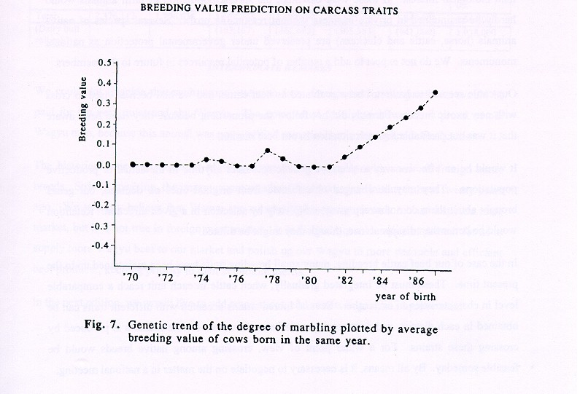
GENERAL VIEW FOR ALL WAGYU BREEDS

Epoch-making events were only picked in the previous sections, which have occurred in the singular processes of Japanese Black breeding. There are three more minor breeds (Table 5), differing obviously in their economic and external traits, and raised in a limited district or region. An all-over breeding and preserving plan, of course, should be applied for all breeds. To my regret, these breeds were not in a cooperating organization yet’ although the aim is the same beef production. Some breeds are possibly in danger, depending on preference of present markets, even if it would be useful resources in the future.

It would actually be a quite difficult problem to preserve discarded farm animals from current production. The animals which lost their economic merit would disappear rapidly without security, and we cannot answer whether or not these are really essential for the future for other than biological interest. If these were essential, the shrunk population of farm animals would hardly be maintained in private business without reasonable profit. Several species of native animals (horse, cattle and chickens) are preserved under governmental protection as national monuments. We do not expect to add a number of potential resources in future to the members.

Our cattle seemed to have not been evaluated as beef cattle, and we had been advised to cross with new exotic breeds. Farmers did not follow the promotion, because they have been aware that it was not profitable for each situation in our beef market.

It would be an effective way to preserve genetic resources anytime in the actual or productive populations. They may be changed or reformed from original ones on demand, but genes brought about them do not sweep away completely by selection in a given direction. Retention would be better than disappearance, though they might be diluted.

In the case of our beef cattle breeding, many small breeding units have been maintained up to the present time. These must be integrated gradually, when cattle in each unit reach a comparable level in characteristics to each other. Several inbred strains accented with different traits can be obtained in each district, and commercial cattle being favorable for the markets is produced by crossing these strains. For a wider point of view, crossing among native breeds would be feasible someday. By all means, it is necessary to negotiate on the matter in a national meeting.

Table 5. Change of population in each beef cattle breed.

Breed | 1960  Head  % | 1965 Head  % | 1970 Head  % | 1975 Head  % | 1980 Head  % | 1985 Head  % | 1990 Head  %
Japanese  Black | 18,151,508  76.4 | 1,4,54,755  81.0 | 1,373,603  86.6 | 1,207,272  86.6 | 1,322,564  86.7 | 1,423,790  86.50 | 1,419,392  85.3
Japanese  Brown | 525,781  22.1 | 309,044  17.2 | 205,708  12.7 | 123,355  8.8 | 135,765  8.9 | 151,432  9.2 | 163,072  9.8
Japanese  Poll | 7,668  0.3 | 7,929  0.4 | 8,593  0.5 | 5,047  0.4 | 3,050  0.2 | 3,292  0.2 | 1,664  0.1
Japanese  Shorthorn | 20,811  0.9 | 22,404  1.2 | 30,164  1.9 | 39,455  2.8 | 47,289  3.1 | 49,380  3.0 | 46,592  2.8
Aberdeen  Angus | --- | 68.4  0.0 | 1,419  0.1 | 2,747  0.2 | 6,102  0.4 | 8.230  0.5 | 16,640  1.0
Hereford | --- | 254  0.0 | 1,346  0.1 | 7,098  0.5 | 9.153  0.6 | 9.876  0.6 | 9,984  0.6
Charolais | --- | --- | 384  0.0 | 476  0.0 | --- | --- | ---
Others | 6,344  0.3 | 1,566  0.1 | 3,236  0.4 | 8.757  0.6 | 1,525  0.1 | --- | 6,656  0.4
Total | 2,376,112 | 1,796,636 | 1,624,465 | 1.394,190 | 1,525,449 | 1,646,000 | 1,664,000
(Dairy bull  calves) |  |  | (163,167) | (462,683) | (505,383) | (941,000) | (1,038,000)

INTERMEDIATE REMARKS

We could not imagine that such strong attention from foreign beef cattle producers would be paid for the very quiet and shy Wagyu. The unexpected footlights, however, is proud of our Wagyu men, because this animal was not qualified sometimes even as Japanese beef cattle.

The historical breeding processes of Wagyu are not comparable with some of foreign cattle breeds. Strictly speaking, the improvement as a beef breed was just initiated about twenty years ago. We strongly believe that Wagyu can compete with foreign breeds in our domestic meat market, but it is not true in foreign meat market. It is the main consideration at present for us to supply more Wagyu beef to our market and polish up our Wagyu to more desirable and efficient beef producer, keeping priority in their economic merits.

In the next edition, we would like to add some successful results in genetic improvement.

APPENDIX

The synopses of the Wagyu Registry Association

I. BUSINESS

Registration of Japanese breeds of cattle

Guidance, evaluation on genetic performance of cattle, and promotion of the organized breeding plan for breeding stocks

Sponsorship of discussion meetings and short-courses for “Wagyu” production

Publication of the books on the registry

Other necessary business relating to “Wagyu” registration

II. REGISTRATION SYSTEM

Three breeds of Japanese cattle, Black, Brown (Kochi strain) and Poll, are included in our registration. For each breed, we are adopting a selective registration system.

As the black breed is the major breed, accounting for about 85% of total Japanese cattle population, we describe the registration for the black breed as a representative one.

In the latest revision on the regulations for each registry class, effective since April 1, 1989, the requirements for high performance registry were revised completely; although those of fundamental and reserved classes were limited for only minor revision.

The breeding stock registry was repealed in this revision in order to introduce a new flexible system for cattle in the breeding unions. There are 3 classes of registry: fundamental, reserved and high performance.

The regulations are as follows;

There are 3 classes of registry: fundamental, reserved and high performance classes.

1. Fundamental – The reserved registry is admitted for cattle which are produced and raised in the territory of the same improvement union. They must fulfill the following terms:

They must be descendants from registered parents and grandparents.

They must have the calf registry certificate issued before the weaning stage.

Bulls must be scored over 80 points, and cows and heifers must be scored over 77 points.
Both male and female must be judged during 14 and 30 months of age.

They must be progeny of jparents which have not produced and abnormal calf.

2. Reserved – The reserved registry is admitted for cattle which are produced and raised in the territory of the same improvement union. They must fulfill the following terms:

They must be progeny of registered parents and grandparents.
Their sire must score over 80 points, and their dam must be scored over 78 points.

They must be progeny of parents which have not produced any calf exhibiting a genetic defect.

They must be progeny of parents which were qualified by their superior reproductive performance.

Bulls must b score over 82 points, and cows and heifers over 80 points at the growing stage from 14 to 30 months of age.

3. High Performance – The high performance registry is admitted for cattle with the fundamental registry or the reserved registry as an advanced registry class. The cattle being eligible for this class must fulfill the following terms:

GENERAL

They must be progeny of registered parents and grandparents.

They must exhibit superior reproductive performance. The individual and its parents have to be clean from any genetic defect gene.

JUDGING

Requirement for judging score at the registry for this class was repealed. The result of the descriptive classification score is provided to applied cattle and recorded as the official record.

To be eligible for this registry class, cows must score over 80 points, and bulls must score over 82 points at the fundamental or reserved registry.

In the previous requirement, the animal which cleared the same score level at the registration can be eligible for this registry class.

Cattle proven to be excellent by progeny records on judging score and carcass grading will be eligible for this class.

REPRODUCTIVE

The first calving must be earlier than 28 months of age for females.

The averaged calving interval for more than 3 calvings must be less than 400 days.

PROGENY RECORD

Cows applied for this class must have had more than 2 offspring which scored more than 80 points. In this requirement, one of 2 offspring can substitute by slaughtered animal of which carcass was graded to A-5, A-4 and B5 in carcass grading standard.

Bulls applied for this class must have more than 25 offspring which scored more than 80 points. Furthermore, they must clear a given criteria on progeny testing records.

4. New Flexible Breeding Stock System – Cattle registered breeding stock registry in old registry system and for high performance registry can be eligible for breeding stocks of each breeding stock union.

Breeding stocks are replaced flexibility according to the breeding purposes of each breeding stock union. Any stock does not have permanent qualification, as they are a kind of project team to produce bull candidates for successors.

The selection standard for breeding stocks should be depend on both of judging score and PBV on carcass traits under consideration.

Address:
Wagyu Registry Association
546-2 Nijoden-cho Karasuma-oike
Nakagyo-ku Kyoto
604 Japan
Tele (075) 221-5856
TAX (075) 251-0377

